State of the State: Social Media
January 3, 2018 | 12PM

Hashtags:
- #StrongNonprofits
- #NYSOTS
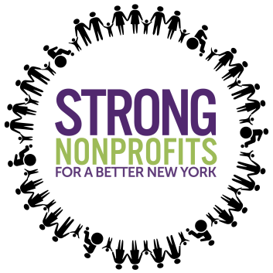
- #SOTS2018
Handles:
- @NYGovCuomo
- @CarlHeastie
- @LeaderFlanagan

Find your Senator here or Assemblymember here. Be sure to tweet and/or send the below posts on Facebook!
Tweets:
- #StrongNonprofits help our communities thrive! We need your help .@NYGovCuomo .@CarlHeastie .@LeaderFlanagan in supporting the future of #NY #humanservices here: https://www.strongnonprofitsny.org/ #NYSOTS #SOTS2018

- #HumanServices are vital to #NY! .@NYGovCuomo .@CarlHeastie .@LeaderFlanagan Learn more about why we need to protect #StrongNonprofits here: https://www.strongnonprofitsny.org/ #NYSOTS #SOTS2018
- .@NYGovCuomo .@CarlHeastie .@LeaderFlanagan: 58% of #HumanServices workers have college or AA degrees + 36% have bachelor’s degrees or higher. We need investments to maintain our skilled workforce so we can continue to serve communities across #NY! #StrongNonprofits #NYSOTS

- #StrongNonprofits are responsible for elevating the human potential in our communities, providing critical programs and interventions for all New Yorkers! We need your support .@NYGovCuomo .@CarlHeastie .@LeaderFlanagan #NYSOTS #SOTS2018

- #HumanServices #nonprofits serve 2.5M New Yorkers and employ nearly 870,000 workers. #Nonprofits are an economic engine for #NY! Support our communities .@NYGovCuomo .@CarlHeastie .@LeaderFlanagan #NYSOTS #SOTS2018

Facebook posts:
- @GovernorAndrewCuomo: Strong Nonprofits for a Better New York is a coalition of over 350 #nonprofit #humanservices organizations across the State. This year, we are focusing on concentrated investments in the #humanservices sector in workforce and infrastructure which help our communities thrive! Let’s support our local #nonprofit services and see how you can add your voice to our campaign here: https://www.strongnonprofitsny.org/ #StrongNonprofits #NYSOTS #NY #SOTS2018

- @GovernorAndrewCuomo: Did you know? The nonprofit sector employs 81 percent women and 46 percent people of color. We need critical investments in our workforce and upgrades to our infrastructure so we can continue serving our communities! Support and sign onto our campaign here calling on the State to make investments in our crucial services which uplift New Yorkers from all walks of life. https://www.strongnonprofitsny.org/ #StrongNonprofits #NYSOTS #NY #SOTS2018

- @GovernorAndrewCuomo: #HumanServices #nonprofits serve 2.5M New Yorkers and employ nearly 870,000 workers throughout the State! Not only are #nonprofits are an economic engine for #NY, they represent more than 18 percent of all private sector employment throughout the State. It is vital that you support our workforce and support our campaign here: https://www.strongnonprofitsny.org/ #StrongNonprofits #NYSOTS #NY #SOTS2018
Infographics:

1.
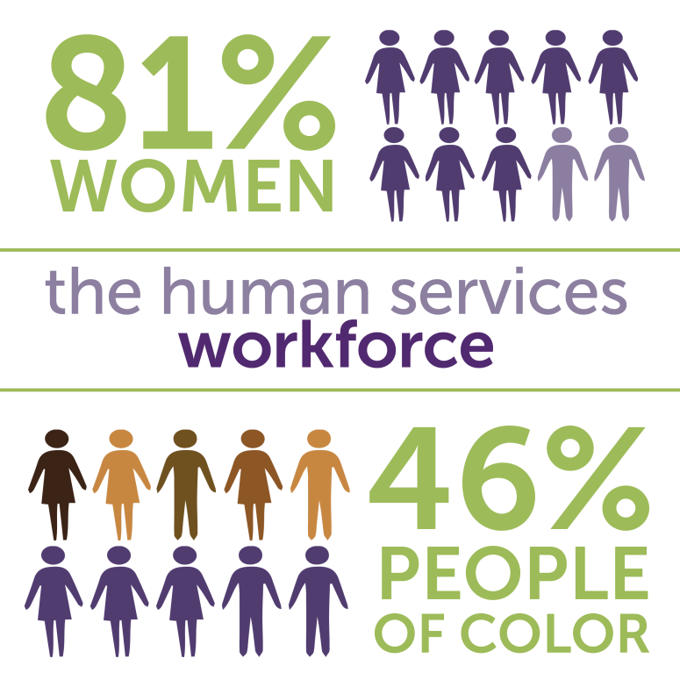

2.
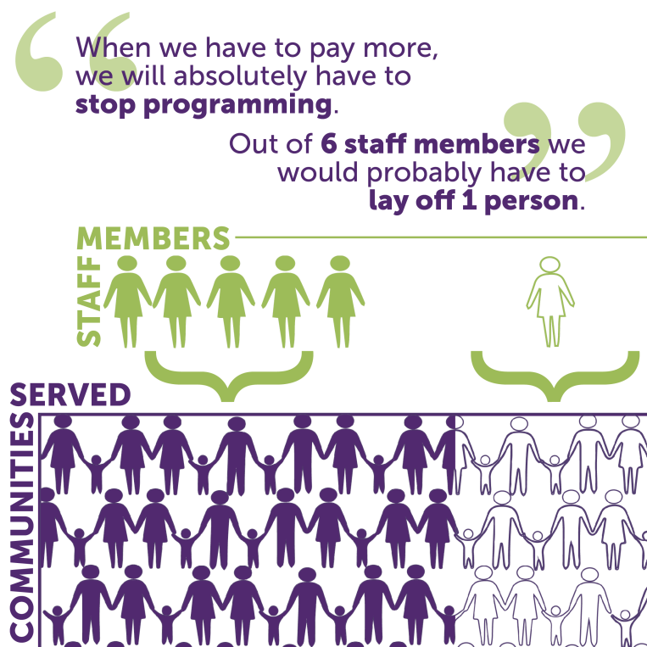

3.
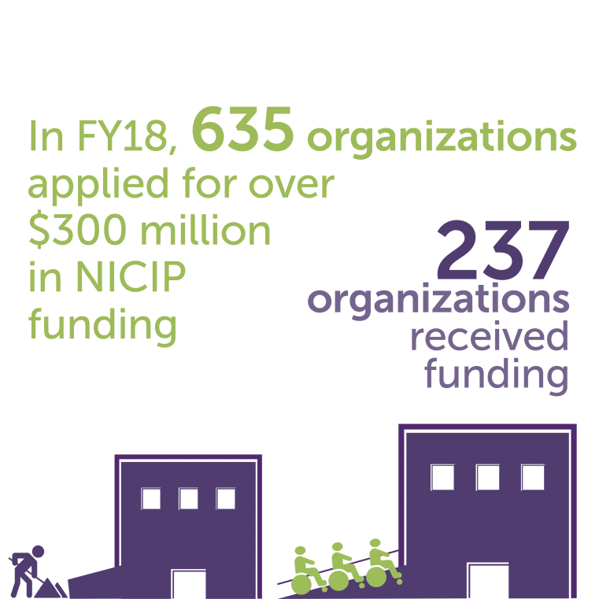

4.
