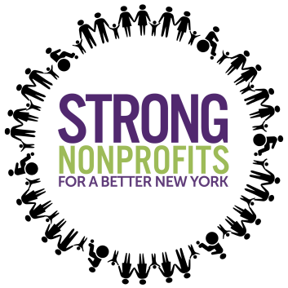

SOCIAL MEDIA ACTION:
Thursday, December 14th
11:00AM – 1:00PM

Help us spread the word that the campaign is back and better than ever! Tweet, Facebook and Instagram to show support for New York’s human services sector and make sure Governor Cuomo knows how important these issues are. Encourage your staff, colleagues, and program participants to join you!

Here’s how you can help us make sure Albany knows human services must be top priority:

1: Follow Us—Tag Us and Retweet/Repost
- @NonprofitsNY (Twitter and Instagram)
- https://facebook.com/NonprofitsNY

2: Use These Hashtags In Your Own Posts:
- #StrongNonprofits
- #HumanServices
- #Nonprofits
- #NY
3: Tag Governor Cuomo (He is our first target, since inclusion in his Executive Budget is our best chance at the funding we need!)
- Twitter: @NYGovCuomo
- Facebook: @GovernorAndrewCuomo
- Instagram: @NYGovCuomo
4: Get Posting and Encourage Your Co-Workers, Staff, and Program Participants to Join You! You can use the graphics and sample posts below, or share your own nonprofit human services story!

Infographics:
1.
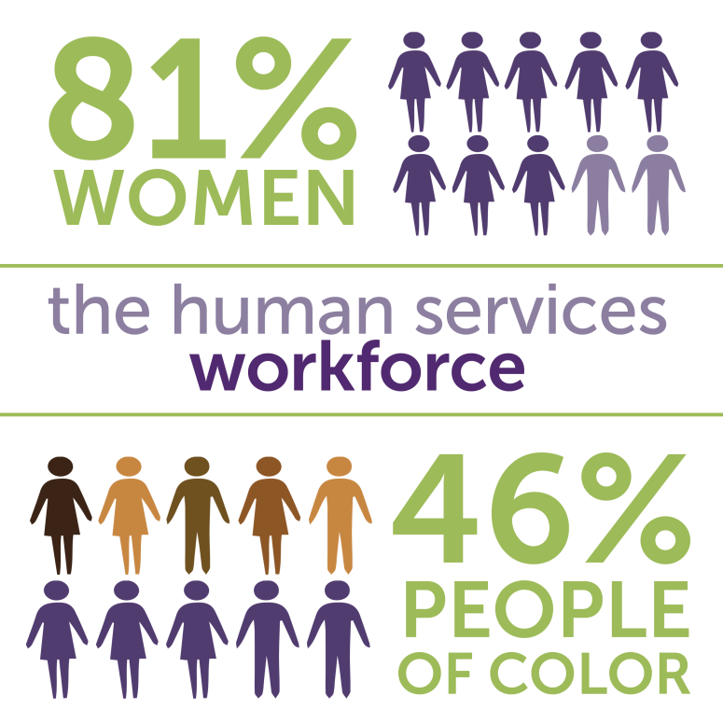

2.
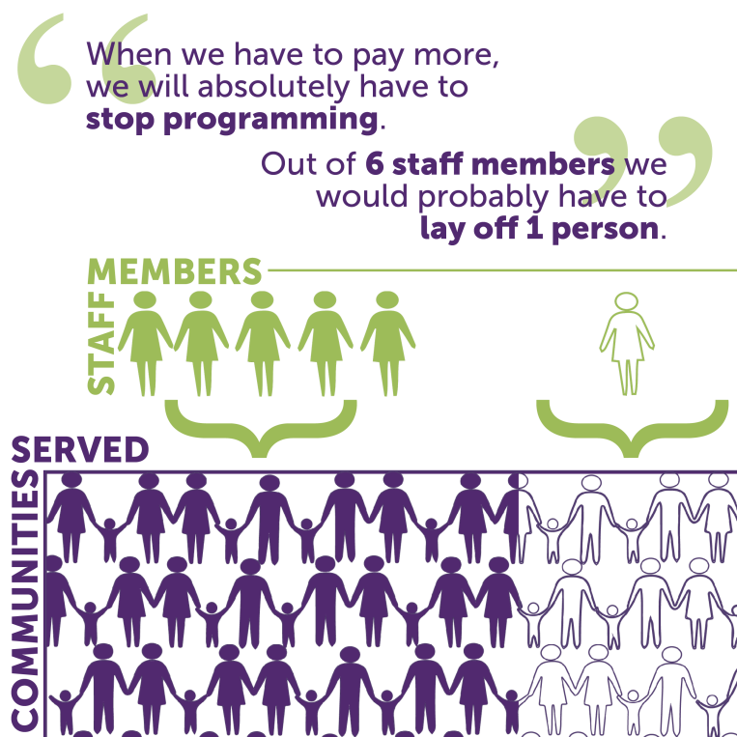

3.
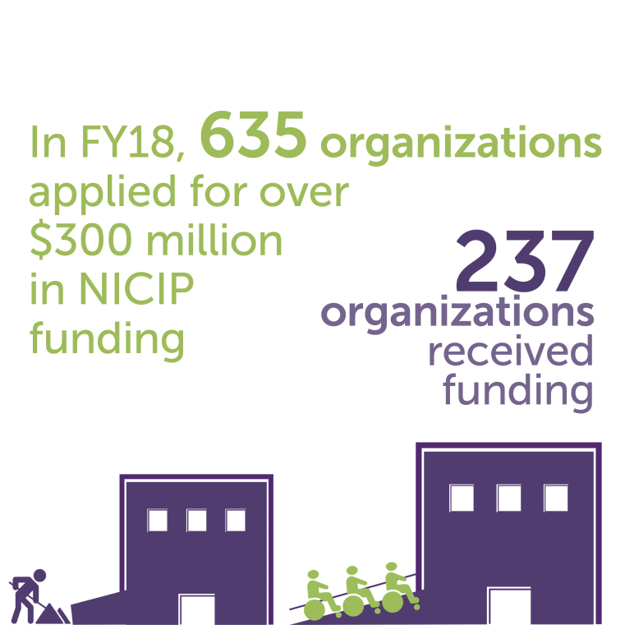

4.
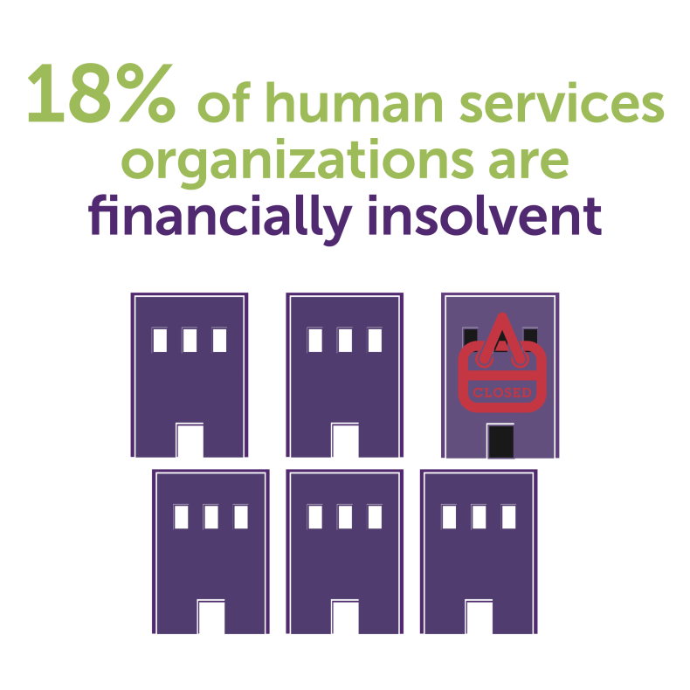

Tweets:
- Did you know? #HumanServices workers are 81% female + 46% people of color. We need investments to maintain this skilled workforce so #nonprofits can continue to serve communities across #NY! Click here: https://www.strongnonprofitsny.orgfor more info about #StrongNonprofits .@NYGovCuomo

- .@NYGovCuomo #StrongNonprofits are responsible for elevating the human potential in our communities, providing critical programs and interventions for all New Yorkers. You must invest in #Nonprofits! https://www.strongnonprofitsny.org/budget
- .@NYGovCuomo #HumanServices #nonprofits serve 2.5M New Yorkers and employ nearly 870,000 workers. #Nonprofits are an economic engine for #NY! Invest in #StrongNonprofits: https://www.strongnonprofitsny.org/budget
- .@NYGovCuomo #HumanServices are vital to #NY! Learn more about why we need to protect #StrongNonprofits here: https://www.strongnonprofitsny.org/
- .@NYGovCuomo #Nonprofits comprise 18% of the private sector workforce throughout the State! We need to support our #nonprofit #humanservices organizations so we can build up our communities. Invest in #StrongNonprofits: https://www.strongnonprofitsny.org/budget

Facebook posts:
- Strong Nonprofits for a Better New York represent over 350 #humanservices agencies throughout the State that provide crucial services to uplift New Yorkers from all walks of life. We need critical investments in our workforce and upgrades to our infrastructure so we can continue serving our communities! The State must ensure these organizations can continue their vital work. We’re looking for your support, @GovernorAndrewCuomo to ensure these investments are made! https://www.strongnonprofitsny.org/budget
- @GovernorAndrewCuomo #HumanServices #nonprofits serve 2.5M New Yorkers and employ nearly 870,000 workers throughout the State! Not only are #nonprofits are an economic engine for #NY, they represent more than 18 percent of all private sector employment throughout the State. It is vital that you support our workforce and support our campaign here: https://www.strongnonprofitsny.org/

