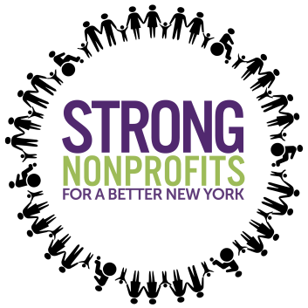
Strong Nonprofits for a Better New York
NICIP Fair Social media

Hashtags:
- #StrongNonprofits
- #BuildingUpNY

Targets:
- @NYGovCuomo
- @CarlEHeastie
- @LeaderFlanagan
- Find your legislator!

Tweets:

- The Nonprofit Infrastructure Capital Investment Program (NICIP) has allowed over 237 human services providers repair, reinforce, expand, and update their physical and technological infrastructure | We need your support! @NYGovCuomo #BuildingUpNY #StrongNonprofits

- The need for nonprofit capital funding is substantial: More than 635 orgs applied to the Nonprofit Infrastructure Capital Investment Program (NICIP) totaling in over $300M! Support investing in nonprofit infrastructure! [@handle] #BuildingUpNY #StrongNonprofits

- Keep this critical Nonprofit Infrastructure Program @NYGovCuomo! Over the last 3 years the $120M to this fund has allowed nonprofits to make capital improvements to better serve and promote more access in our communities! #BuildingUpNY #StrongNonprofits

- We need you to fund the Nonprofit Infrastructure Capital Investment Program (NICIP)! This is an impt step in meeting infrastructure needs of a sector that delivers nearly $6.8B in essential services annually across NYS! [@handle] #StrongNonprofits #BuildingUpNY

- We need to build up the human services sector! Support the Nonprofit Infrastructure Capital Investment Program (NICIP) & promote access for all New Yorkers to sustain our services! #BuildingUpNY #StrongNonprofits

Infographics

- 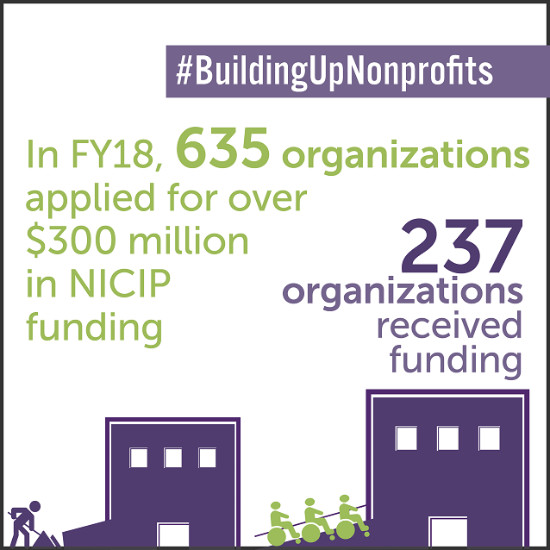

2. 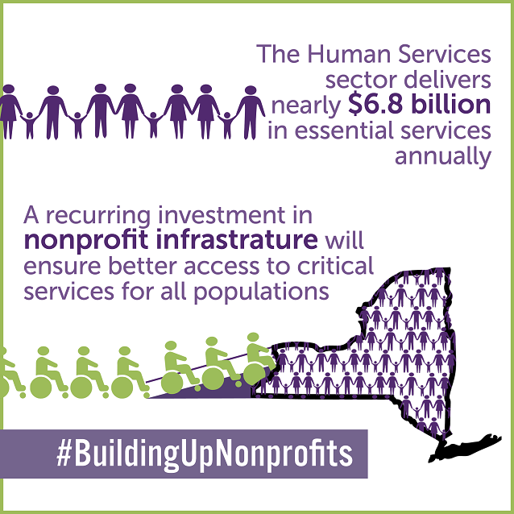

3. 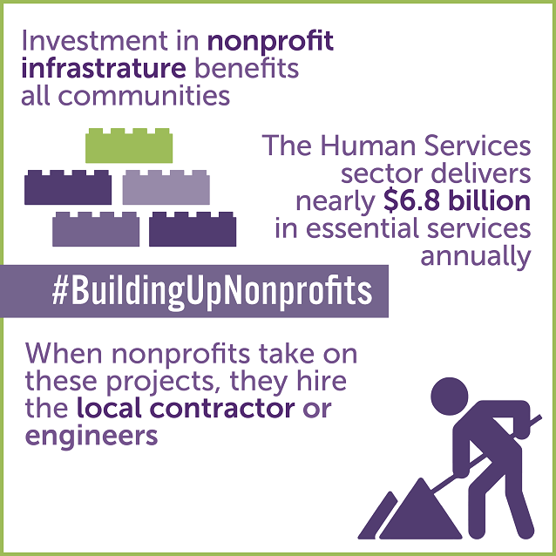

4. 