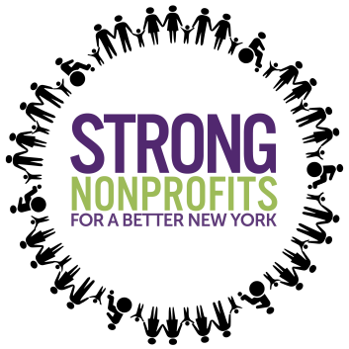

Strong Nonprofits Campaign
Social Media Toolkit

Handles:
- @NonprofitsNY
- https://facebook.com/NonprofitsNY

Hashtag:

- #StrongNonprofits
- #HumanServices
- #Nonprofits
- #NY

Infographics:
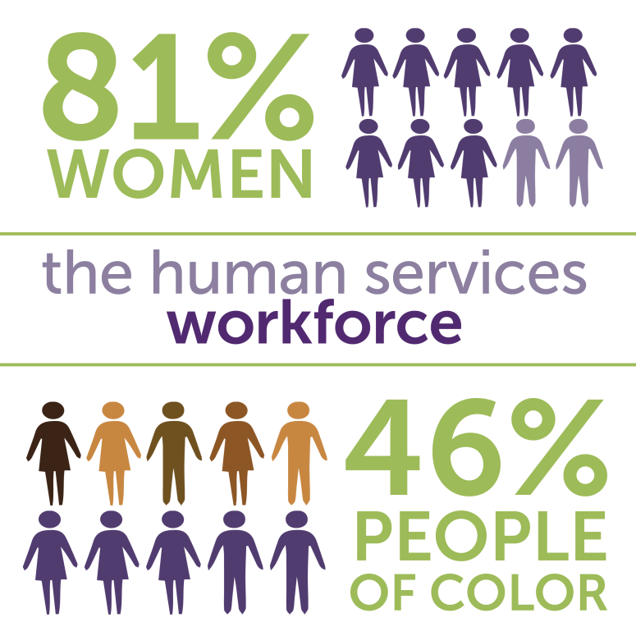
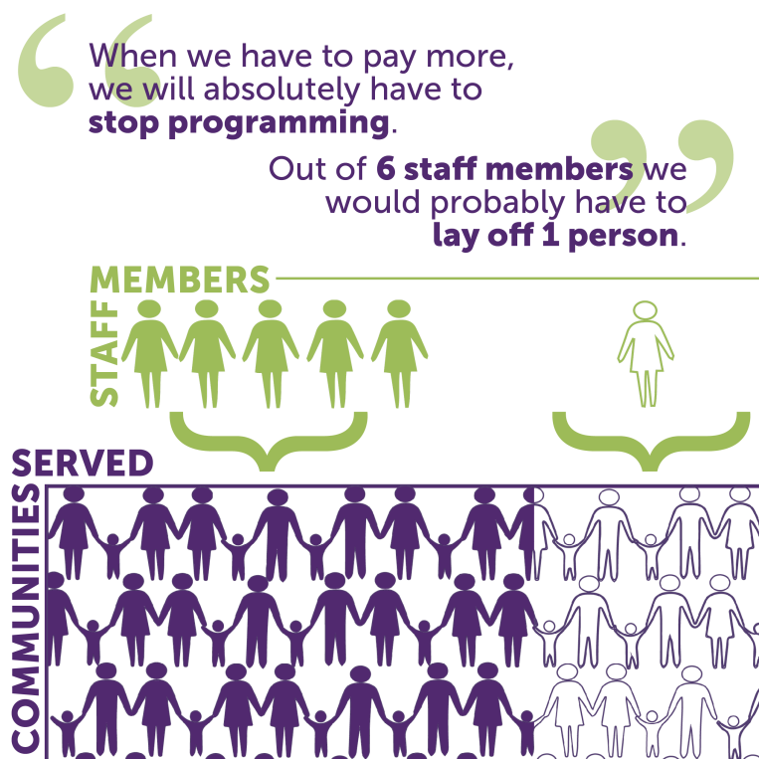
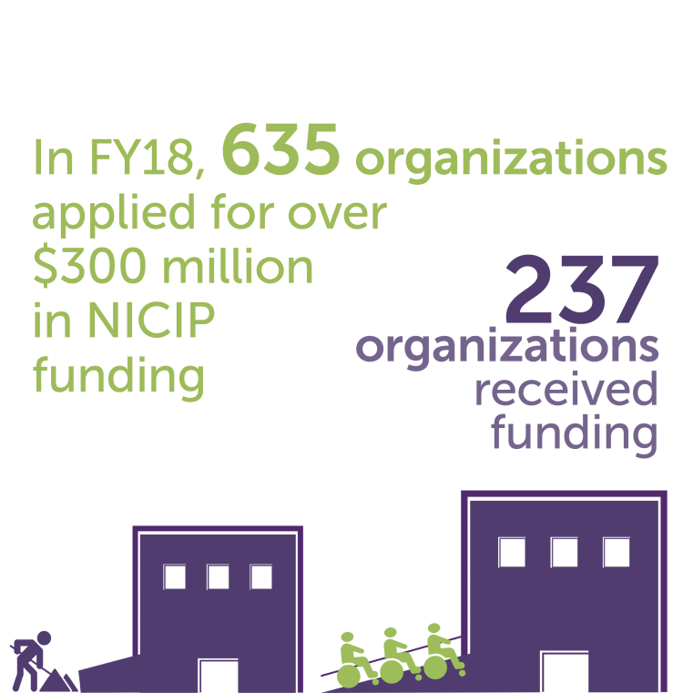
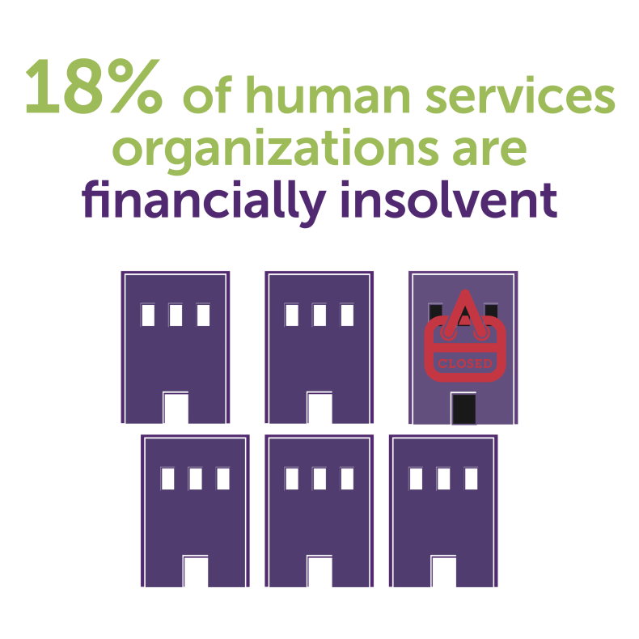
Tweets:
- #StrongNonprofits help our communities thrive! Check out how you can learn more about the State Campaign supporting the future of #NY #humanservices here: www.strongnonprofitsny.org

- #HumanServices are vital to #NY! Learn more about why we need to protect #StrongNonprofits here: www.strongnonprofitsny.org
- Did you know? #HumanServices workers are 81% female + 46% people of color. We need investments to maintain this skilled workforce so #nonprofits can continue to serve communities across #NY! Click here http://bit.ly/2j2K0O6 for more info about #StrongNonprofits

- #StrongNonprofits are responsible for elevating the human potential in our communities, providing critical programs and interventions for all New Yorkers. Support #nonprofits and sign onto our campaign today! www.strongnonprofitsny.org

- #HumanServices #nonprofits serve 2.5M New Yorkers and employ nearly 870,000 workers. #Nonprofits are an economic engine for #NY! Support our communities & sign onto our campaign here: www.strongnonprofitsny.org

