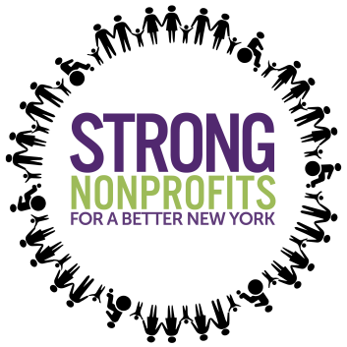
Strong Nonprofits for a Better New York
1/15/2019 Bake Sale Social Media

Hashtags:
- #StrongNonprofits
- #HumanServicesKneadDough
- #NonprofitsNeedTheirPayDay

Targets:
- @NYGovCuomo
- @CarlEHeastie
- @AndreaSCousins
- Find your legislator!

Tweets:
- We encourage you [@handle] to stop by our Nonprofit Bake Sale today at 10:30AM! NY’s commitment to human services can’t be half-baked #StrongNonprofits #NonprofitsKneadDough

- .@NYGovCuomo for goodness’s cakes, fund the COLA. Stop deferring $140m in wage adjustments for human services workers. #StrongNonprofits #NonprofitsKneadDough
- Don’t leave our sector incomplete! We need the support of NYS to ensure our communities thrive – commit to investing in our vital workforce and infrastructure #StrongNonprofits #NonprofitsKneadDough

- Human services workers are 81% female + 46% people of color. Missing ingredient? Equitable wages to maintain this skilled workforce that serves communities across NY! #StrongNonprofits #NonprofitsKneadDough

- Human services nonprofits serve 2.5M New Yorkers and employ nearly 870,000 workers. Nonprofits are an economic engine for #StrongNonprofits #NonprofitsKneadDough

- Don’t let our infrastructure crumble. Support $100m in funding for nonprofit infrastructure. #StrongNonprofits #NonprofitsKneadDough

- When government contracts fail to include funding increases to reflect the minimum wage increase, nonprofits are forced to make other cuts to fill a widening gap. Invest $25 million to fund the minimum wage in this year’s budget to strengthen nonprofits and the communities they serve. #StrongNonprofits #NonprofitsKneadDough

Graphics - To be included with tweets
-Save each graphic as an image file

